javax.servlet.ServletException: java.lang.InternalError: name is too long to represent

Fix error weblogic

File setDomainEnv.cmd

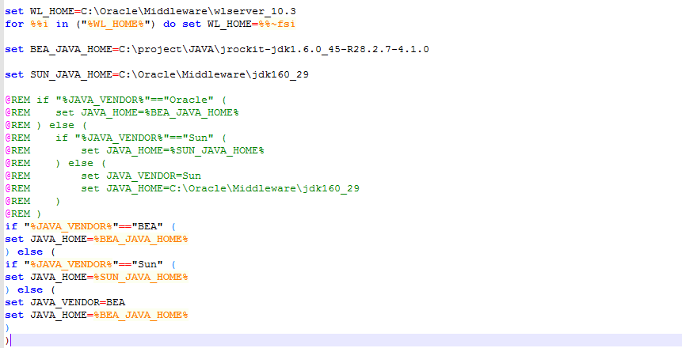

add

add

@REM